Pallet Classification Table:

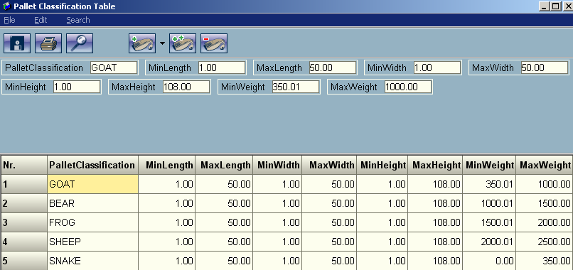

This was added as a special feature for RedPrairie to help support the WMS swapping logic. Before every trailer is sent to us, each pallet is assigned a classification based on the dimensions and weight. This is not something that is used by load designer during palletizing or loading but is instrumental to the RedPrairie-Ortec interface.

Field Definitions:
PalletClassification: A string that will be used to uniquely identify a grouping of pallets.
MinLength: The minimum length a pallet can be to fit in this classification.
MaxLength: The maximum length a pallet can be to fit in this classification.
MinWidth: The minimum width a pallet can be to fit in this classification.
MaxWidth: The maximum width a pallet can be to fit in this classification.
MinHeight: The minimum height a pallet can be to fit in this classification.
MaxHeight: The maximum height a pallet can be to fit in this classification.
MinWeight: The minimum weight a pallet can be to fit in this classification.
MaxWeight: The maximum weight a pallet can be to fit in this classification.

Many users will probably set the dimensions to be something very large so only the different weights are taken into consideration when classifying a pallet.

